# Kristian Pereira

# kdperei2

# ECE 417 – Multimedia Signal Processing

# MP2: Vision Based Person Identification (Face Recognition)

Results

Note that the columns represent Nearest neighbor with k=1 and k =5.

Raw Data

**Random Matrix**

|  |  |  |  |  |  |  |
| --- | --- | --- | --- | --- | --- | --- |
|  | Trial 1 | Trial 2 | Trial 3 | Trial 4 | Trial 5 | Average |
| 5 | 0.675 | 0.7625 | 0.7375 | 0.7625 | 0.7875 | 0.745 |
| 1 | 0.8 | 0.825 | 0.8375 | 0.8125 | 0.8375 | 0.8225 |

**PCA**

|  |  |
| --- | --- |
|  | Accuracy |
| 5 | 0.8 |
| 1 | 0.9625 |

|  |  |  |  |  |
| --- | --- | --- | --- | --- |
|  | 90x70 | 45x35 | 22x17 | 9x8 |
| 5 | 0.7375 | 0.775 | 0.8 | 0.825 |
| 1 | 0.8875 | 0.9 | 0.9125 | 0.9875 |

**Average Face:**

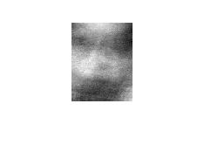

It can clearly be seen that faces have common features, this includes:

1. Nose: the light patch at the center of the image
2. Eyes: the two dark patches in at the top of the image
3. Mouth: the dark region at the bottom of the picture

Using the mean image to center the data set allowed for better classification because of these common features.

**Eigenfaces:**

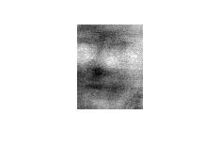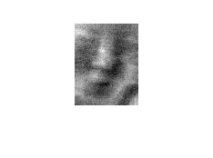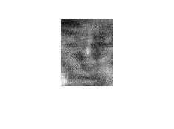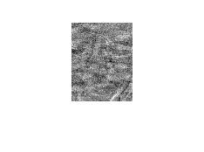

The eigenfaces show details that are common to the faces in the dataset. The eyes, mouth, nose and shape of the face can be seen in the eigenfaces.

**Energy of the dataset:**

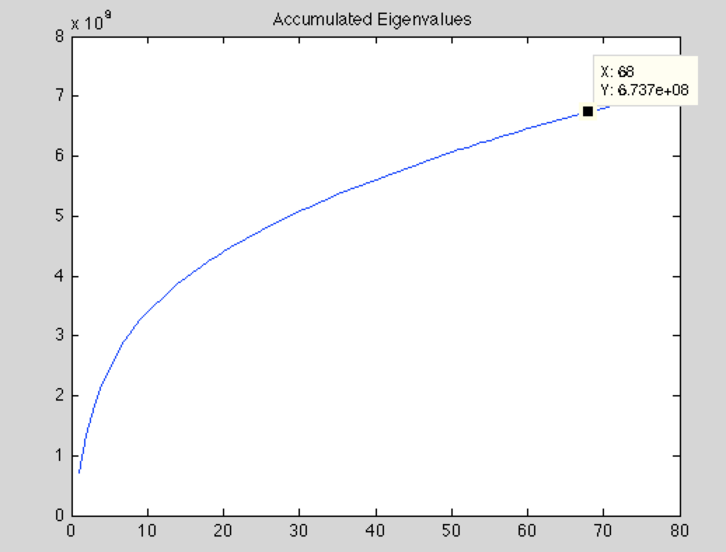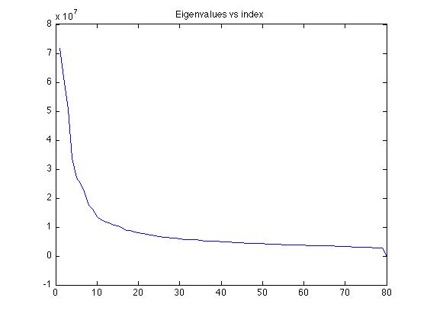

It was found that 68 eigenfaces held 95% of the data’s energy meaning the basis of the eigenvectors could be reduced from 80 to 68, thus reducing the number of computations.

Discussion:

For PCA the image we were trying to classify was “removed” from the data set of the classifier to make search more realistic i.e. You are not going to have the exact same image when doing face recognition. Moreover the classification is trivial for k= 1 in nearest neighbor.

**Number of Pixels vs accuracy:**

The accuracy of the image classification improved as number of pixels reduced. This could be attributed to the complexity of the pictures. By reducing the resolution we were able to remove unnecessary detail. This would not work for a dataset with vast number of classes as the classifier may need subtle details to classify.

**Random Projection:**

Random projection was slightly better than using the raw data showing that the basis made by the eigenfaces was more useful for the classifier.

**PCA :**

PCA clearly was the superior method for classification as it removed unnecessary detail while highlighting the common features.